

# LAB – FILE

**Graphics and Animation Tools - Lab**

**CSGG 4101**

Name – Rishank Gupta

Roll No. – R100217062

Sap id – 500062486

Course – B. Tech CSE-OSS

Batch – 2

*Under the guidance of…*

Dr.Durgansh Sharma

Associate professor

Department of Cybernetics

School of Computer Science(SOCS)

**EXPERIMENT – 10**

**Objective:** To create a building

**Steps:**

1. Open new file
2. Delete contents of the file
3. Insert a new cube
4. Scale and extrude it to create a platform which will act as the base for the building
5. Select the upper faces and extrude it to appropriate length
6. Repeat step 5 to create multiple floors
7. Now for the rooftop, press I and hold inwards followed by extruding to give it a feel of boundary
8. Press Ctrl+R to place loop cuts for creating windows
9. Then press I
10. Repeat Steps 8 and 9 where you want to place windows
11. Now Create material with required colours and assign it to required face.
12. Save the file and render the final model.
13. Finish.

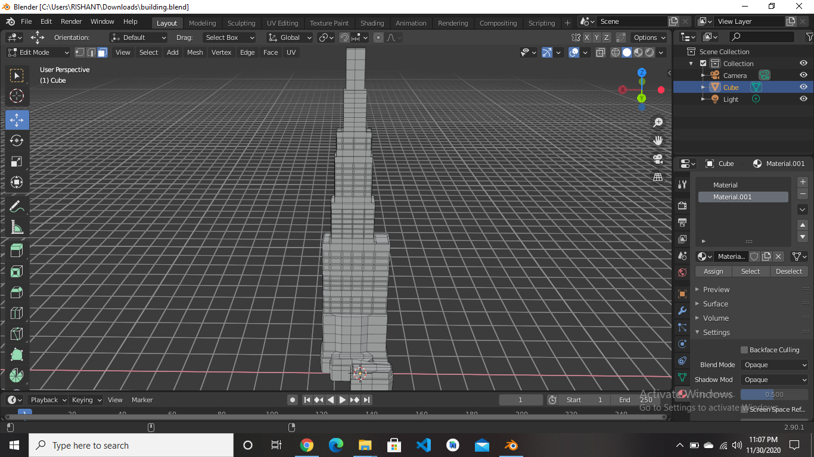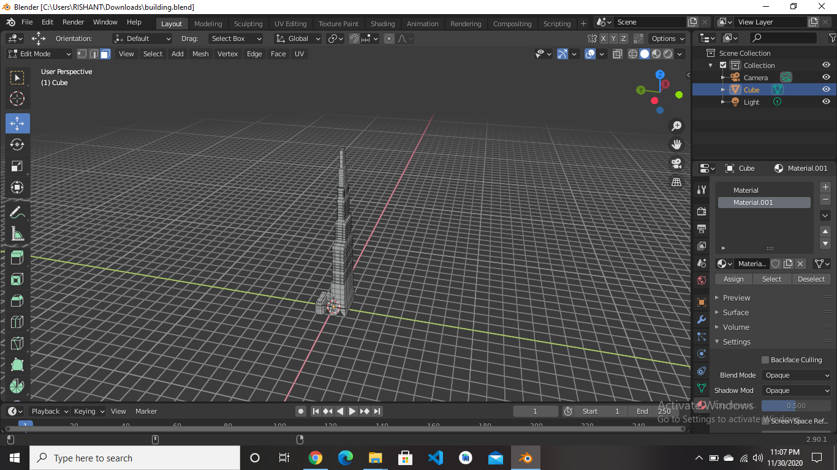

**Link:** [**https://drive.google.com/drive/folders/1DiecsZ31HNtn_iroalUSKyPzNmRS4Bwx?usp=sharing**](https://drive.google.com/drive/folders/1DiecsZ31HNtn_iroalUSKyPzNmRS4Bwx?usp=sharing)